**Coding portion of project :**

Analog pin-6

Digital pin-14

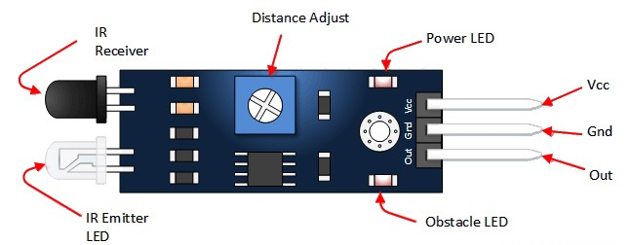

Code:

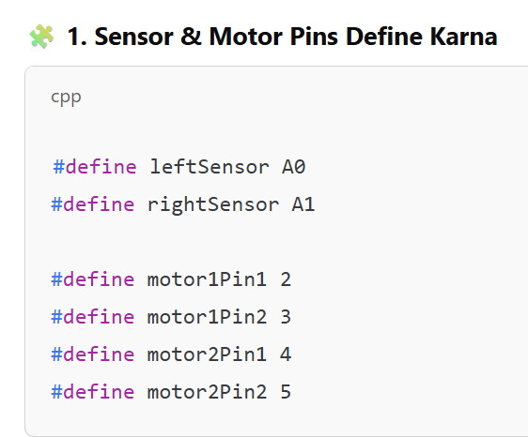

Yeh humne **IR sensors** ke liye input pins aur **motors** ke liye output pins define kiye.

**Interview question :**

**• Coding / Logic:**

* Line following ka logic kya tha?
* Agar dono sensors white surface detect karte hain toh robot kya karega?
* Agar left sensor black aur right sensor white detect karta hai toh kya hoga?
* Tumne robot ko sharp turn kaise karwaya?

Code me digitalRead() aur digitalWrite() ka kya matlab hai?

**•**

**2. Setup Function – pinMode & Serial Start:**

**setup() function sirf ek baar chalta hai** – yahan hum sensor input aur motor output declare karte hain.

**9600-** Isme ek baud rate set karna padta hai — matlab kitni speed se data transfer hoga.

**3. loop: jab tak chalta rahega board on hai**

4: call function :

**Prerequisite: motor-** power-5 volt (high) , ground -0(low) – motor start basic concept

**Sharp turn ke liye**, ek motor ko **forward** chalana padta hai aur doosri motor ko **backward** chalana padta hai.

digitalWrite():

iska matlab hai **us pin ko 5 volt de do**.

ka matlab hai **us pin ko 0 volt (ground) kar do**.

# IoT Vehicle Accident Detection Tracking System

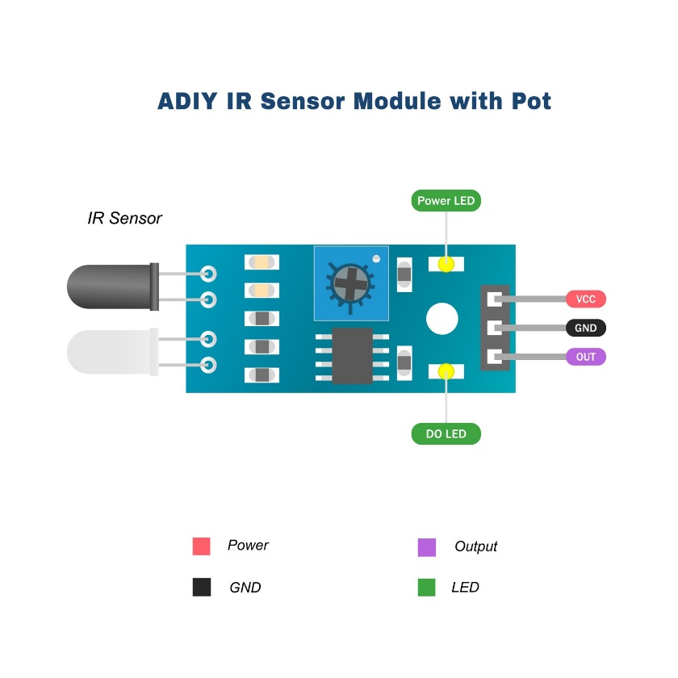

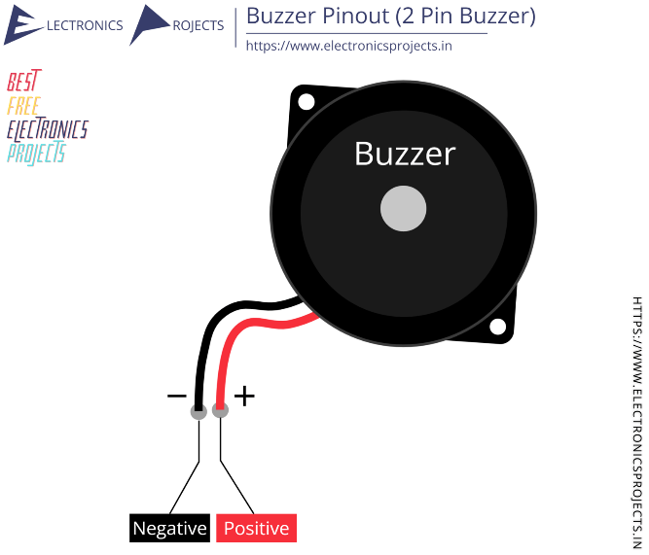

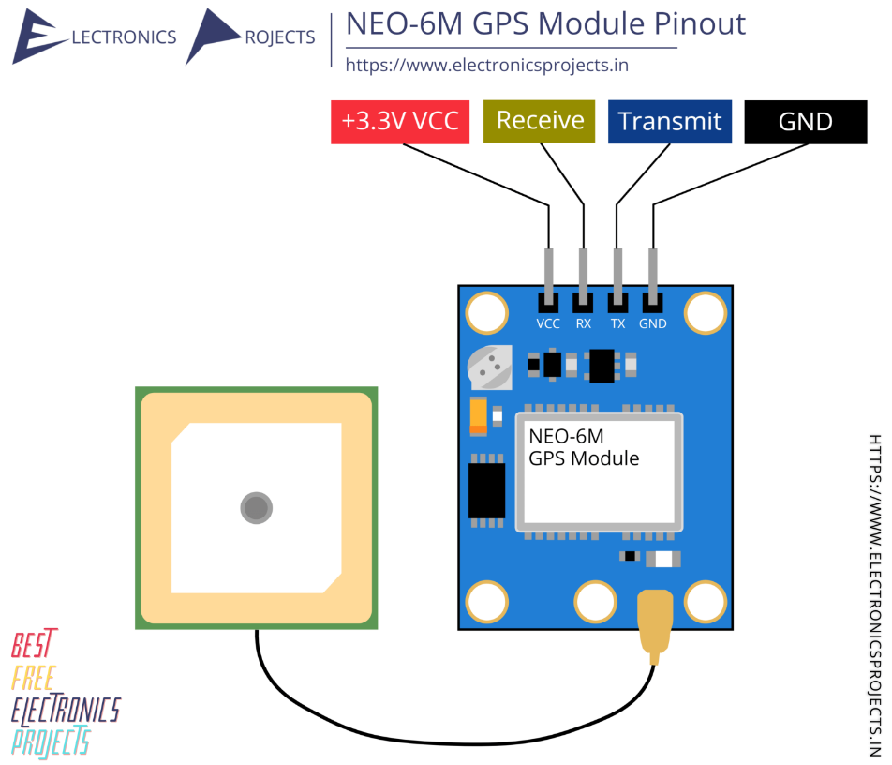

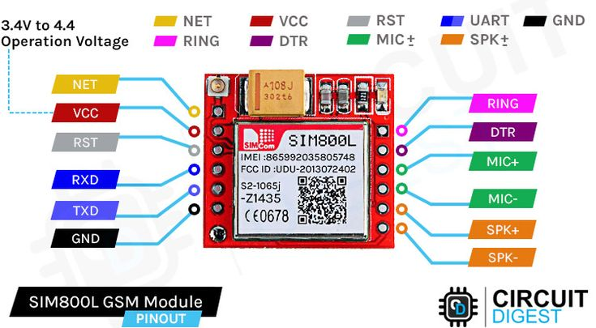

Accelerometer:

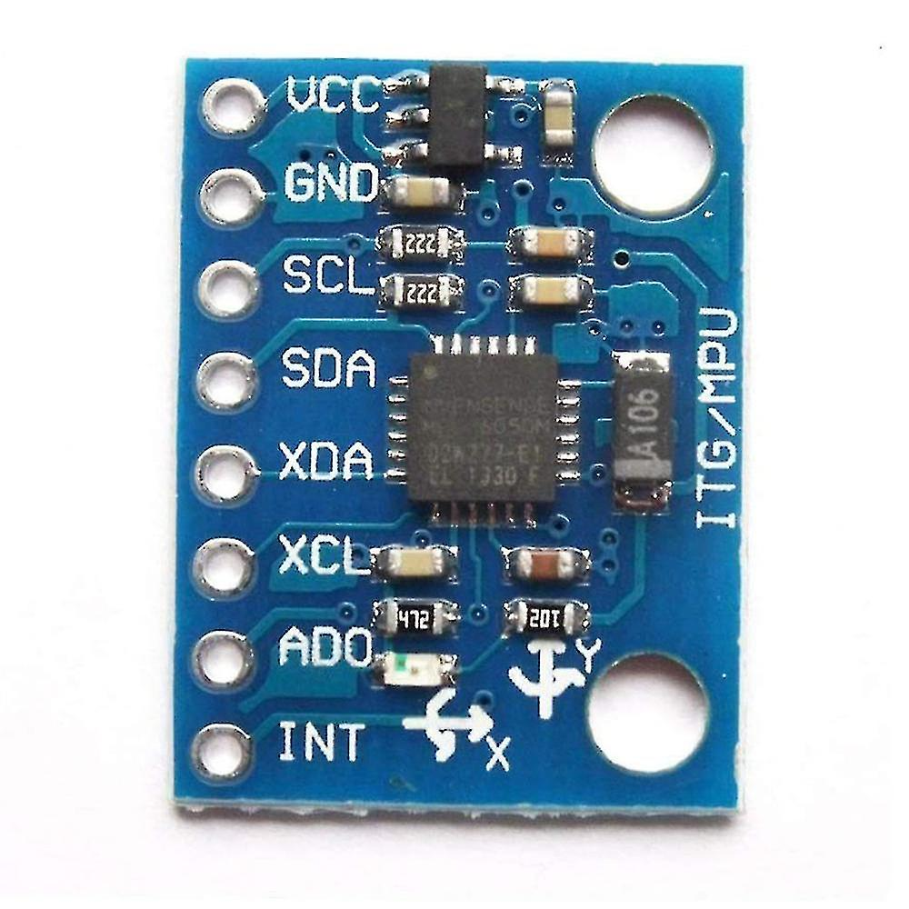

Gas sensor : analog pin 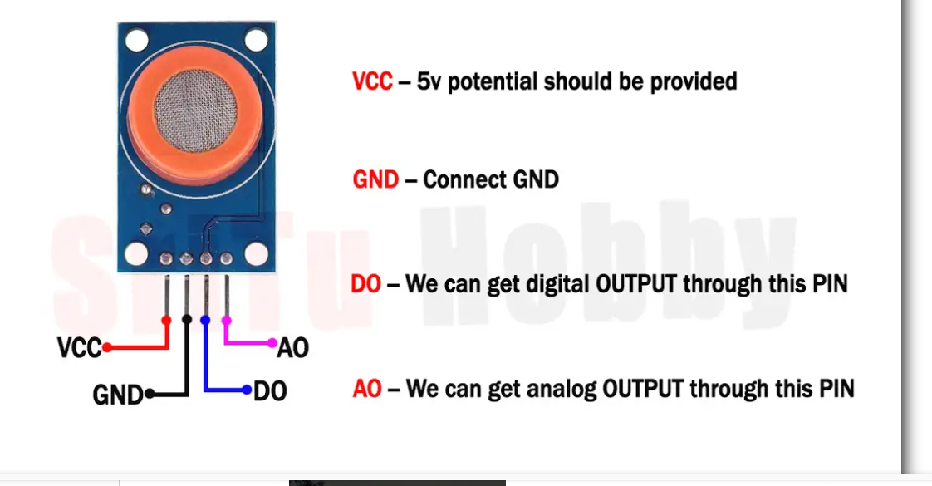

Code:

#include <Wire.h>: •

- It allows **I2C communication** between your **Arduino** and devices like **MPU6050( acceleoneter)**.

-MPU6050 communicates using **SDA (A4)** and **SCL (A5)** pins over I2C.

**#include <MPU6050.h>**

**📌 Purpose:**

* This is a library that **makes it easy to access data** from MPU6050 (like ax, ay, az).
* It simplifies reading **acceleration and gyroscope values**.

**Ir sensor** • It gives a value between **0 to 1023** depending on the light received (typically from IR reflection from the eye).

• **Aankh khuli (open)** hoti hai to **IR rays reflect hoti hain** aur receiver tak pahuchti hain.

• 😴 **Aankh band (closed)** hoti hai to reflection **nahi hoti**, to IR rays receiver tak **nahi pahuchti**.

| **Voltage** | **AnalogRead Value** |
| --- | --- |
| 0V | 0 |
| 2.5V | 512 |
| 5V | 1023 |

Accelertion:

.function calling :

**Smart shelter :**

**DHT11 / DHT22 Sensor**  
– Measures temperature and humidity inside the shelter.

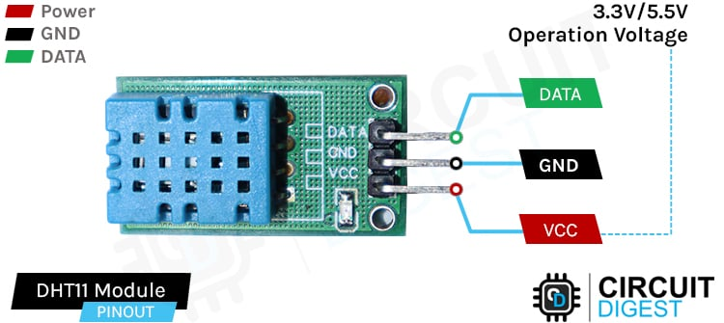

**Gas Sensor (MQ-2 / MQ-135)**  
– Detects harmful gases (like smoke, CO₂) for air quality monitoring.

| **Value Range** | **Interpretation** |
| --- | --- |
| 0–200 | Clean air |
| 200–400 | Light gas presence |
| **>400** | **High gas detected** |

We are using in resume only –

Rain sensor :

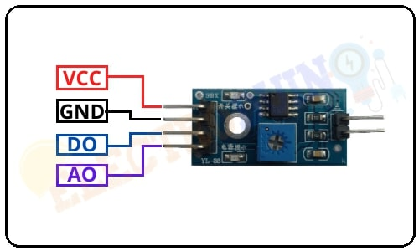

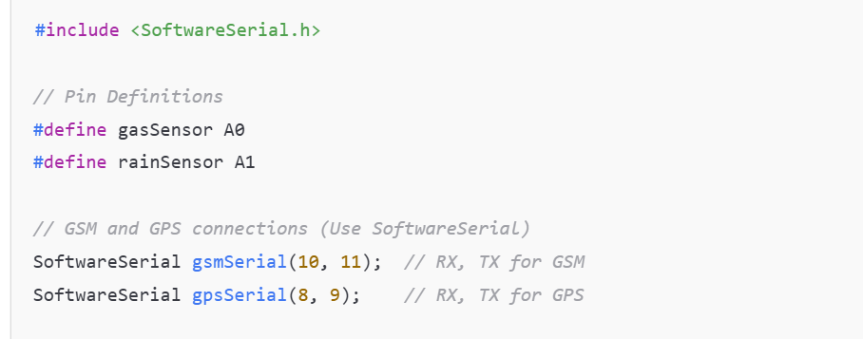

**Automated Data Extraction from Online Stores Using UiPath RPA:- BOT**

In this project, I developed an RPA bot using UiPath that automatically visits online shopping websites like Amazon or Flipkart, searches for specific products (e.g., ‘Mobile Phones’), scrapes relevant information (name, price, rating, availability), and stores it in an Excel or CSV file.

The bot was designed using UiPath activities like Open Browser, Data Scraping, Write Range, and loops to handle multiple pages.

It saves manual effort, works faster, and provides real-time market comparison. This kind of automation is useful for businesses in price tracking, competitor analysis, or inventory updates.”

IMPORTANT POINT- fuzzy7 selector , strict selector

Ye data maine **Excel file** ya **CSV** mein store kiya using **Write Range activity.**

gar multiple pages hote hain to maine **pagination** handle kiya using Next button selector